Bs"d
Can you believe it?
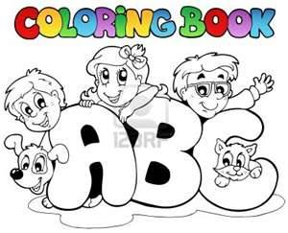
This is the end of the year!
This year….

- I succeed at…………………………………………………………………………
- I learned that….…………………………………………………………………….
- I wanted that……………………………………………………………………….
- I was surprised from….…………………………………………………………
- I found out that………………………………………………………………………
- I asked that……………………………………………………………………….
- I was angry about……………………………………………………………………
- I was happy when……………………………………………………………………….
- I understood that……………………………………………………………………….
- I was excited about………………………………………………………………
- I was afraid of……………………………………………………………………….
- I saw that……………………………………………………………………….
- I hoped that……………………………………………………………………….

