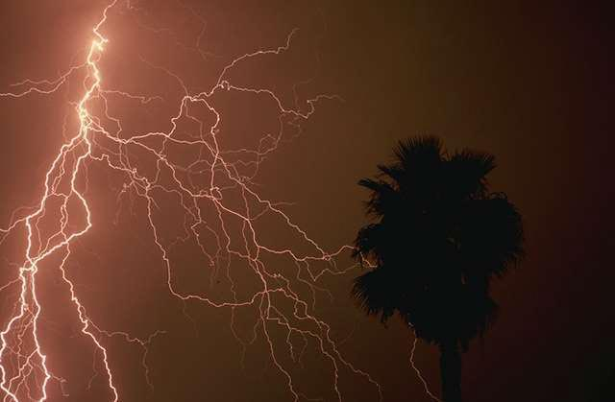

**Sunglasses**

**Scarf**

**Boots**

**Socks**

**Cap**

**Shirt**

**Wool hat**

**Fan**

**Shorts**

**Shirt**

**Dress**

**Gloves**

**Shoes**

**Dress**

**Ribbon**

**Hat**

**Vest**

**WINTER**

Help to the Helokitti to arrive to the winter through the winter clothes!

**Bow**

**Umbrella**

**Sandals**

**Boots**

**Coat**

**Sweater**

**Scarf**