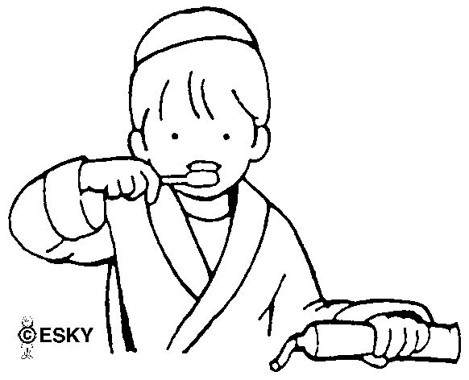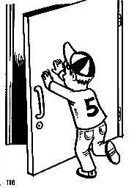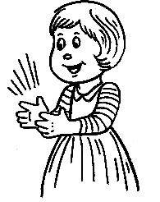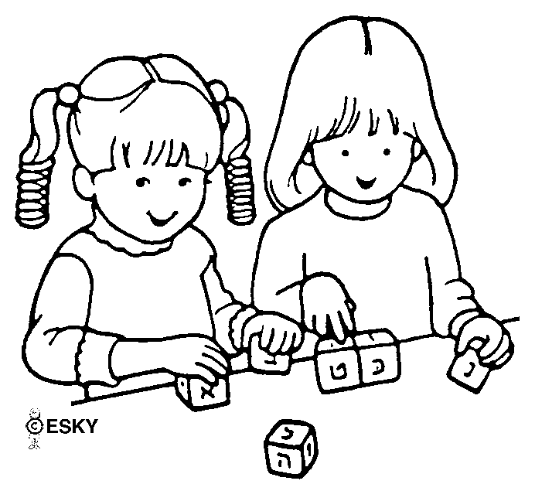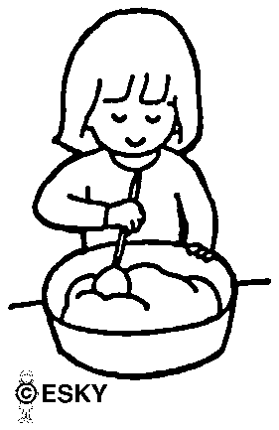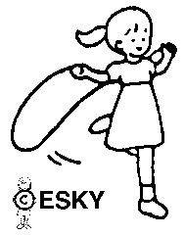

________________________________________________________

________________________________________________________

________________________________________________________

________________________________________________________

________________________________________________________

________________________________________________________

________________________________________________________

Write sentences:

Past Simple