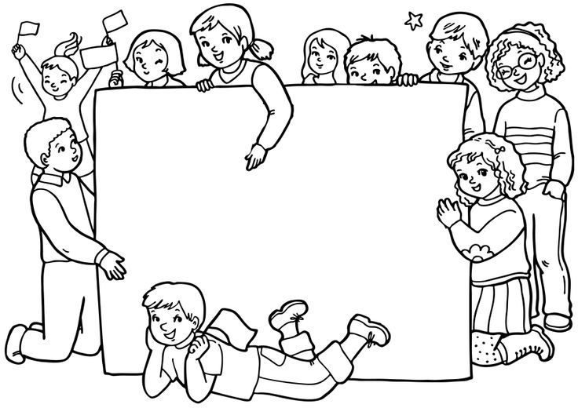

**Keep up the good work!**

Good luck!

Marcelle.



**Keep up the good work!**

Good luck!

Marcelle.

