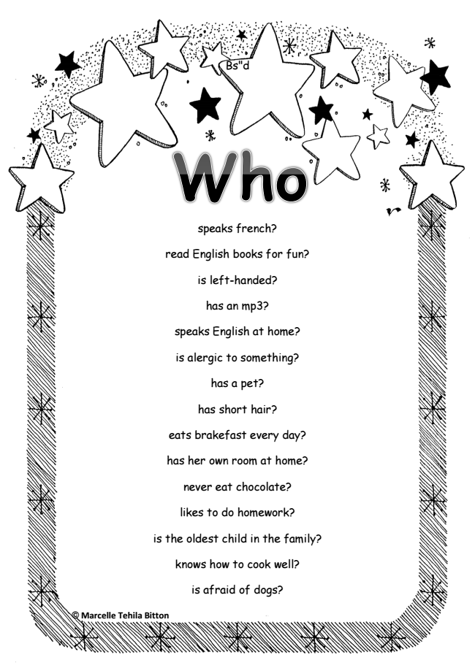

© Marcelle Tehila Bitton
Bs"d
speaks french?
read English books for fun?
is left-handed?
has an mp3?
speaks English at home?
is alergic to something?
has a pet?
has short hair?
eats brakefast every day?
has her own room at home?
never eat chocolate?
likes to do homework?
is the oldest child in the family?
knows how to cook well?
is afraid of dogs?

