חודש ניסן



מזל החודש

טלה

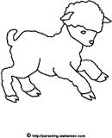

חֹדֶש ________.

|  |  |  |  |  |  |  |
| --- | --- | --- | --- | --- | --- | --- |
| ראשון | שני | שלישי | רביעי | חמישי | שישי | שבת |
|  |  |  |  |  |  |  |
|  |  |  |  |  |  |  |
|  |  |  |  |  |  |  |
|  |  |  |  |  |  |  |
|  |  |  |  |  |  |  |

_______________________________________________________________

_______________________________________________________________

_______________________________________________________________

_______________________________________________________________