Colors
1. Match the colors.צבעו כל דלי בצבע אחר וכתבו באנגלית את שם הצבע
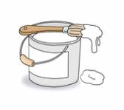

2. Do the following exercises.כתבו את השם של החיי לפי הסיפור
- The is white. ( donkey, dog, panda )
- The brown. ( sheep, mouse, bear )
- The green. ( fox, frog, fish )
- The blue. ( horse, hen, rabbit )
- The red. (duck, bear, bird )
write the correct color.השלימו את הסיפור

bear, bear, what do you see?
I see a bird looking at me.
bird, bird, what do you see?
I see a duck looking at me.
duck, duck, what do you see?
I see a horse looking at me.
horse, horse, what do you see?
I see a frog looking at me.
frog,frog, what do you see?
I see a cat looking at me.
cat, cat, what do you see?
I see a dog looking at me.
dog, dog, what do you see?
I see a sheep looking at me.
sheep, sheep, what do you see?
I see a fish looking at me.
fish, fish, what do you see?
I see a teacher looking at me.
3. Answer the questions and color the animal.כתבו את הצבע נכון וצבעו את החיה
- What color is the 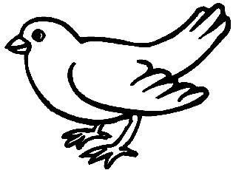bird? It is .
- What color is the sheep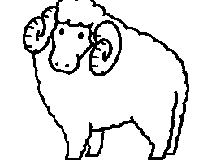? It is .
- What color is the 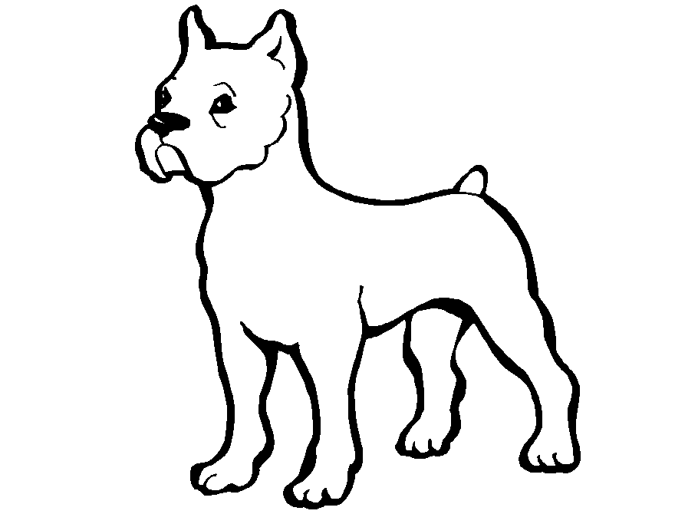dog? It is .
- What color is the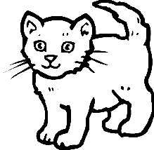 cat? It is .
- What color is the 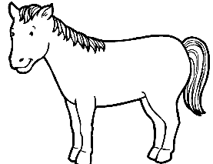horse? It is .

4. Write a sentenceכתבו את המשפט בסדר הנכון
horse /The / blue / is/ . Example: The horse is blue. 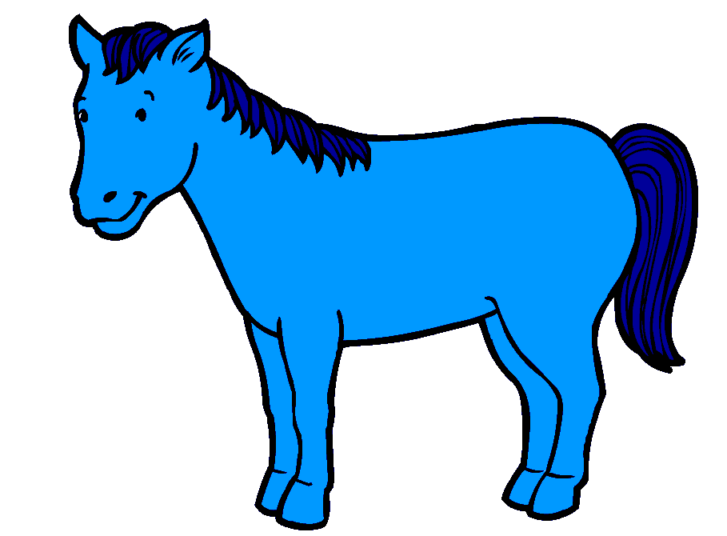

green /frog / The / is . 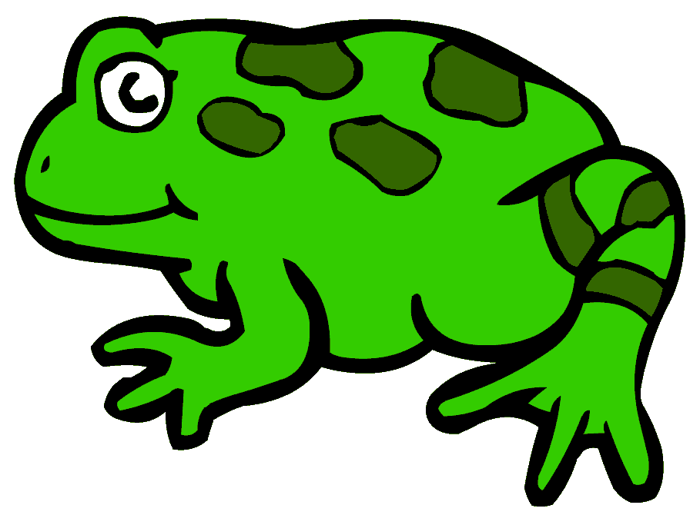
sheep /The / is/ black / . 