BS"D

Descriptive sentences

Describe the picture. You can use the words in the box.
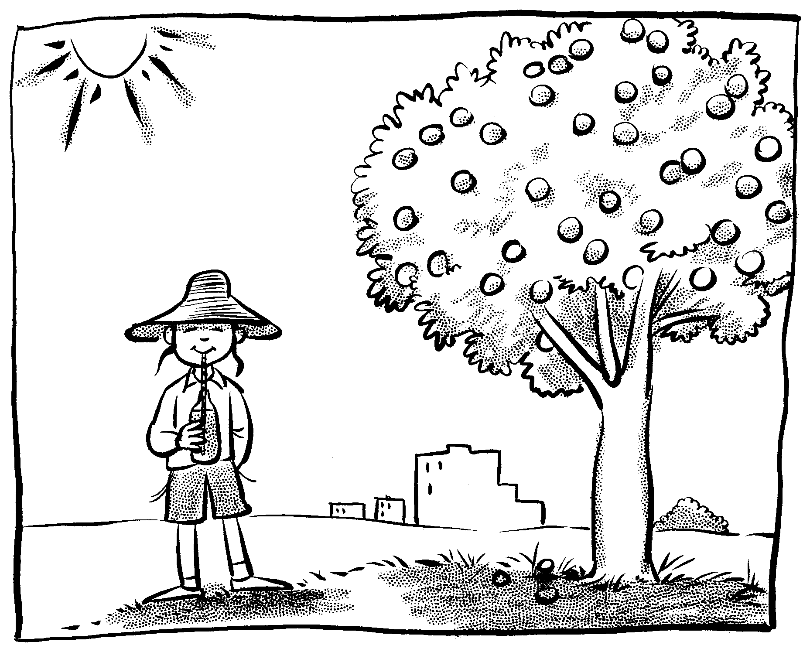.
Subjects: boy, apples, sun, grass, tree, hat,
Adjectives: wide, red, green, hot, happy, tall, near the tree,
in the sky, on the tree.

________________________________________________________________________________________________________________________________________________________________________________________________________________________________________________________________________________________________________________________________________________________________________________________________________________________________________

