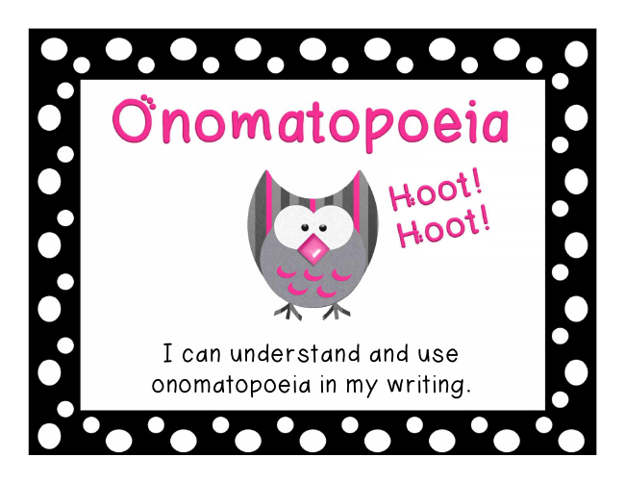
I can understand and use onomatopoeia in my writing.

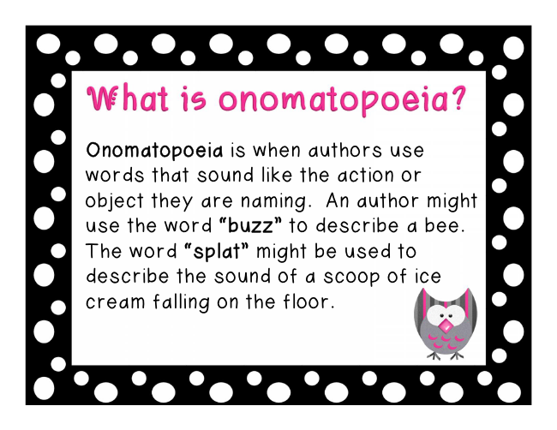
Onomatopoeia is when authors use words that sound like the action or object they are naming. An author might use the word “buzz” to describe a bee. The word “splat” might be used to describe the sound of a scoop of ice cream falling on the floor.

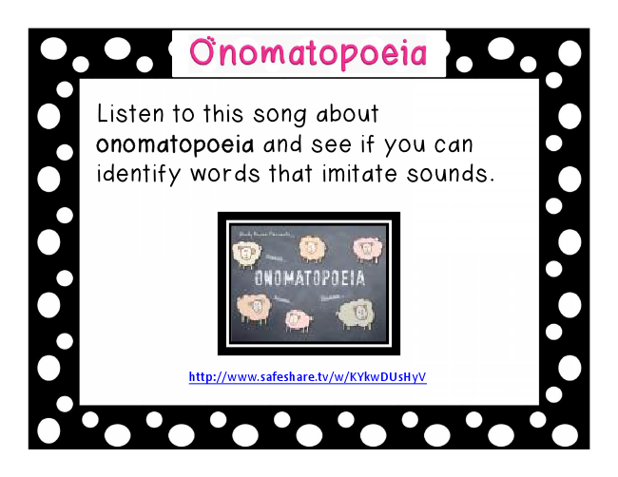
Listen to this song about onomatopoeia and see if you can identify words that imitate sounds.
http://www.safeshare.tv/w/KYkwDUsHyV

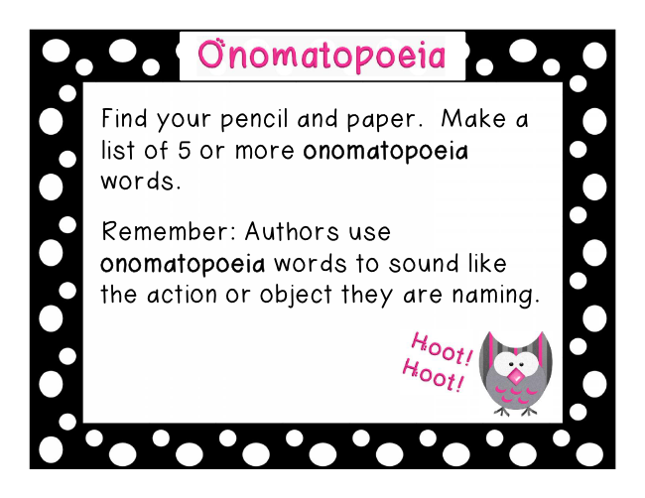
Find your pencil and paper. Make a list of 5 or more onomatopoeia words.
Remember: Authors use onomatopoeia words to sound like the action or object they are naming.

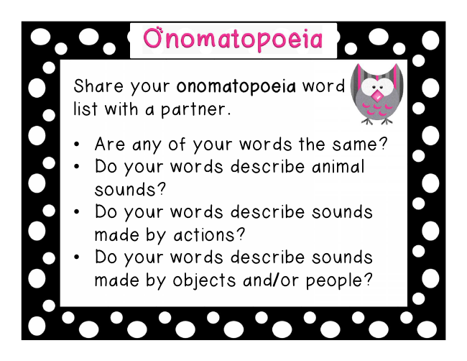
Share your onomatopoeia word list with a partner.
• Are any of your words the same?
• Do your words describe animal sounds?
• Do your words describe sounds made by actions?
• Do your words describe sounds made by objects and/or people?

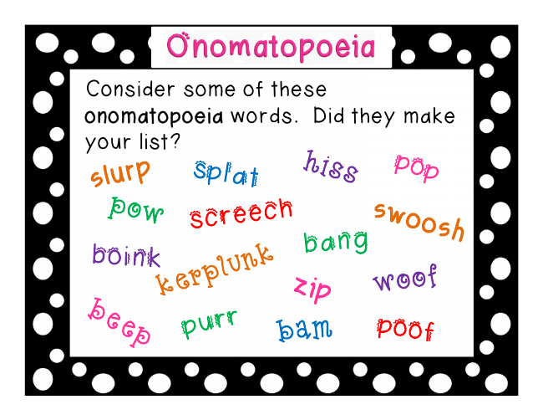
Consider some of these onomatopoeia words. Did they make your list?

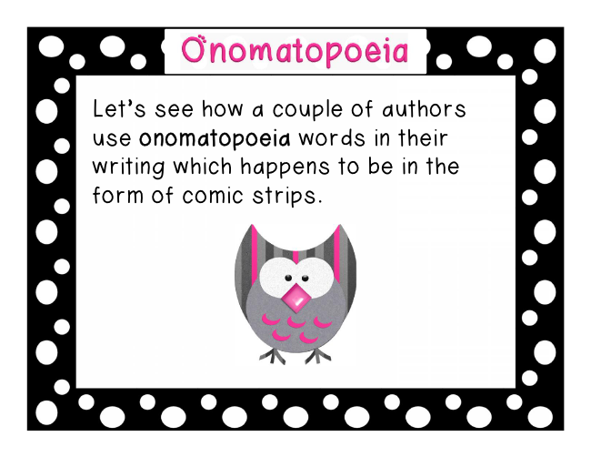
Let’s see how a couple of authors use onomatopoeia words in their writing which happens to be in the form of comic strips.

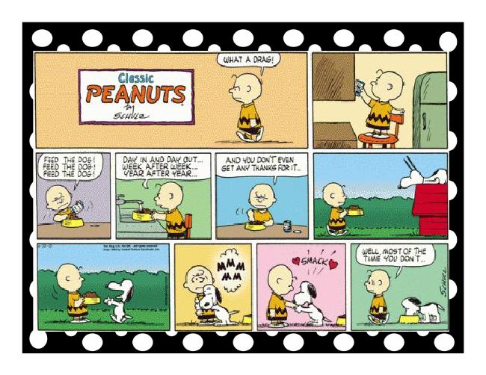

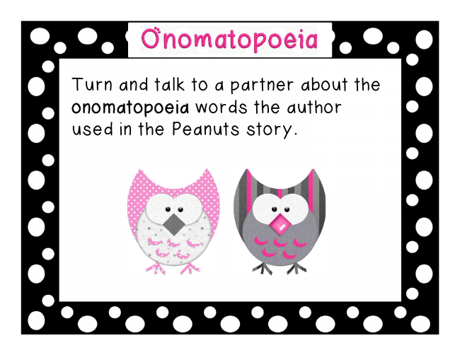
Turn and talk to a partner about the onomatopoeia words the author used in the Peanuts story.

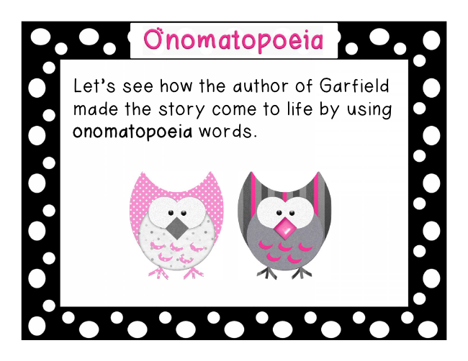
Let’s see how the author of Garfield made the story come to life by using onomatopoeia words.

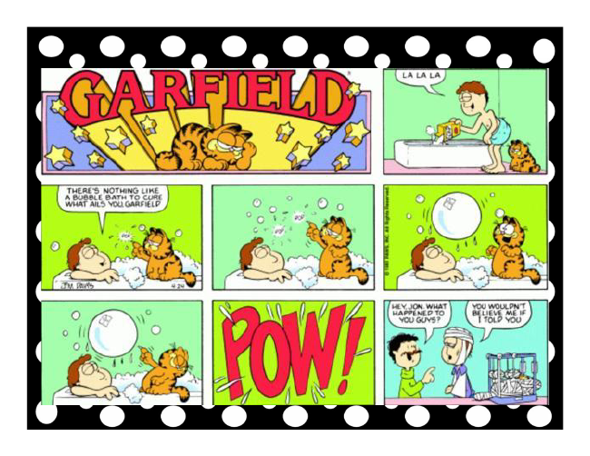

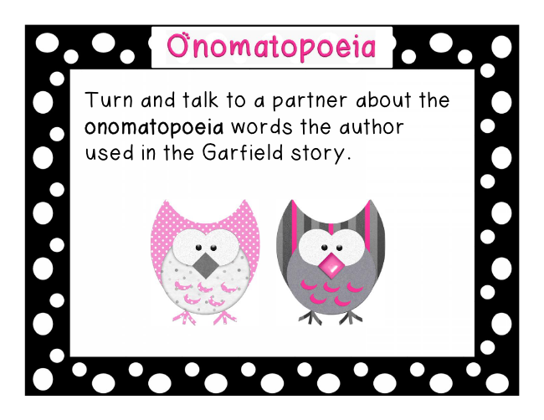
Turn and talk to a partner about the onomatopoeia words the author used in the Garfield story.

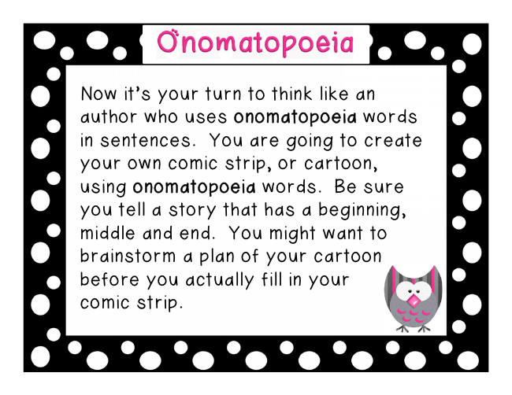
Now it’s your turn to think like an author who uses onomatopoeia words in sentences. You are going to create your own comic strip, or cartoon, using onomatopoeia words. Be sure you tell a story that has a beginning, middle and end. You might want to brainstorm a plan of your cartoon before you actually fill in your comic strip.

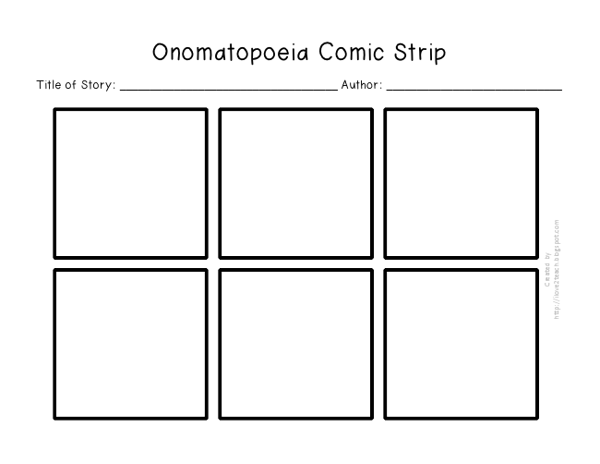
Onomatopoeia Comic Strip
Title of Story: ____________________________________ Author: _____________________________

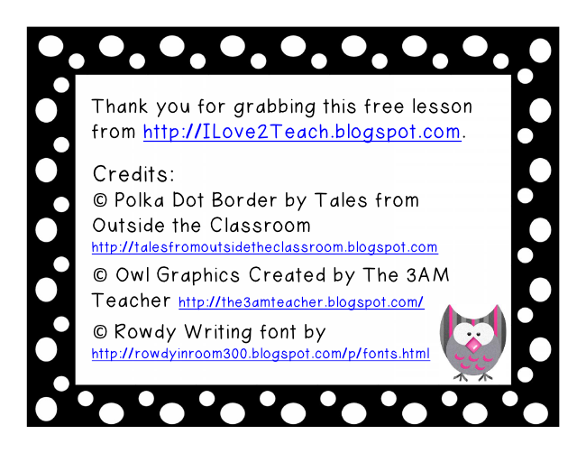
Thank you for grabbing this free lesson from http://ILove2Teach.blogspot.com.
Credits: © Polka Dot Border by Tales from Outside the Classroom http://talesfromoutsidetheclassroom.blogspot.com © Owl Graphics Created by The 3AM Teacher
http://the3amteacher.blogspot.com/ © Rowdy Writing font by http://rowdyinroom300.blogspot.com/p/fonts.html

